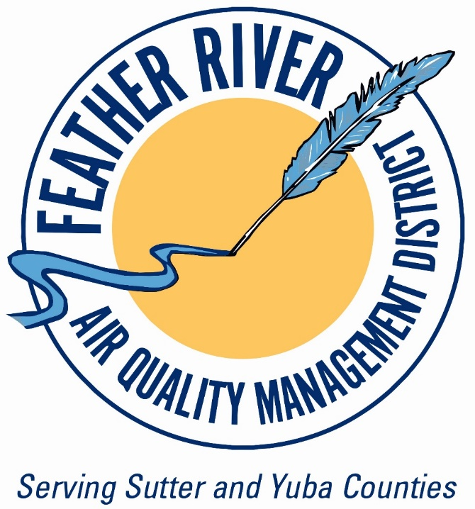

***Feather River Air Quality Management District***

***Board Member Handbook***

***Fifth Edition (January 2025)***

###### *“The Legislature finds and declares that local and regional authorities have the primary responsibility for control of air pollution from all sources, other than emissions from motor vehicles.” -* California Health and Safety Code 40000

*Note from the Air Pollution Control Officer/Executive Officer (APCO/EO) –*

*This document is a living document, and staff will be continuing to revise and upgrade it to provide additional detail and clarity. The goal is to provide a high-level understanding of what an Air District is, how an Air District relates to other government agencies, and what the role of both the District Board and the Hearing Board are under the enabling statues. Because it is a living document and the underlying codes are frequently amended, there may be errors and omissions.*

District Overview

The Feather River Air Quality Management District (FRAQMD or District) is a bi-county State Special District (Health and Safety (H&S) Code § 40300, H&S Code § 40700) covering both Yuba and Sutter Counties. In the early 1970s the Legislature created air districts in each County in California which was not already part of air district[1]. In the early 1990s Yuba and Sutter Air Districts agreed to merge, as allowed by state law, and created FRAQMD. The terms of the merger are outlined in the District’s Unification Agreement.

The District is a regional governmental agency similar to the Sacramento Area Council of Governments (SACOG), Yuba Sutter Transit or Sutter-Yuba Mosquito and Vector Control District. The District is charged with enforcing state, federal and District air quality regulations, adopting new regulations as needed and operating related planning and grant programs.

The District has approximately 1,000 sources under permit[2] ranging from small backup generators to gas stations to large power plants. The District also distributes state, federal and local grant dollars to local eligible projects.

Day to day operations are overseen by the Air Pollution Control Officer (ACPO) who also serves as the Executive Officer for the District (H&S § 40750).

The District is fiscally independent of all other local governments in the two-county region.

**District Staff List**

Air Pollution Control Officer/Executive Officer – Christopher D. Brown AICP

**Administration**

Administrative Services Officer/Clerk of the Boards – Shelley Channel

Fiscal Assistant – Maria Ramos

Administrative Assistant – Jeanelle Lim

**Compliance**

Compliance Supervisor – Karla Sanders

Compliance Specialist – Judith Harlow

Compliance Specialist – Justin Demma

Compliance Specialist – Ramiro Martinez

**Planning and Engineering**

Planning and Engineering Supervisor – Sondra Spaethe

Planner - Peter Angelonides

Engineer – Robin Demma

Engineer – Wyllyam Escobedo

District Organization Chart – Figure 1

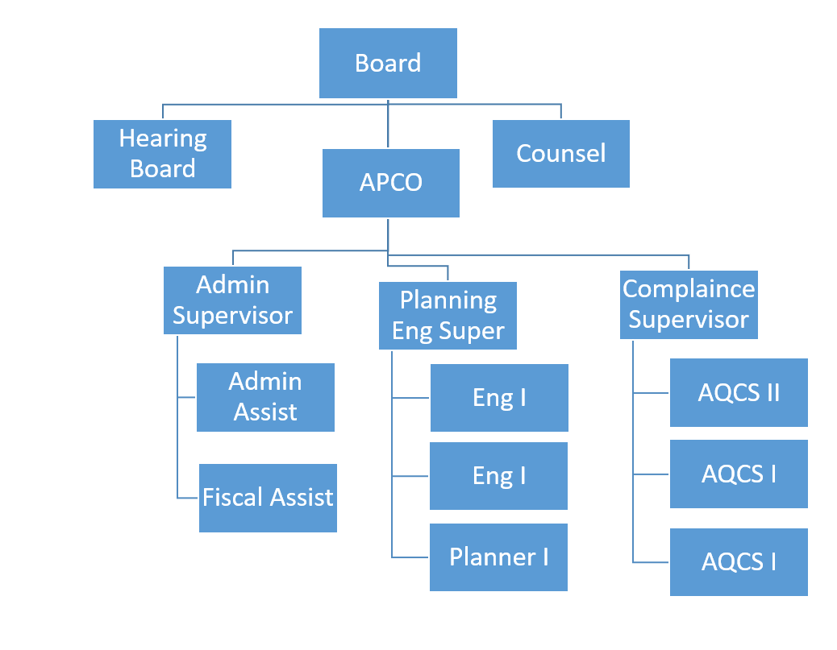

Local Partners

The District is highly dependent on local governments for program coordination. This includes local, state (CalFire) and federal fire agencies (USFS and USAF) for the burn program; local planning departments for land use coordination and California Environmental Quality Act (CEQA) review; local public works departments for concerns about road dust and truck traffic; and school districts for concerns about air pollution near schools. For this reason, much of the District’s work consists of coordinating with these other agencies.

State and Federal Partners

The District’s primary mission is to ensure the local “ambient air[3]” meets state and federal health-based air quality standards. This mission is accomplished by developing plans which are adopted by the FRAQMD Board of Directors (Board) and then submitted for approval to the California Air Resources Board (CARB or ARB) and United States Environmental Protection Agency (EPA). These plans typically contain schedules of future rule adoptions, if the District fails to implement these plans various actions can be taken by ARB and EPA, including suspension of federal highway funding. Plans and Rules require public hearings and Board action, and the District Staff will typically hold a public workshop to gather public comments on any controversial items before they are brought to the Board (H&S Code § 40725).

California Energy Commission

The District has an important role coordinating power plant permitting with the Energy Commission. Neither agency can issue a permit to a power plant (over 50 MW) without having approval from the other agency. While not generally seen by the public this coordination is critical to ensuring a stable power grid.

California Air Resources Board (ARB or CARB)

The ARB Board[4] is appointed by the Governor and the Legislature. Some of the members must be appointed from specified Local Air District Boards. FRAQMD shares a seat on the ARB Board with the other Sacramento Region Districts. Eric Guerra from the City of Sacramento currently serves on the ARB Board representing the Sacramento Region Air Districts (H&S Code § 39510).

While ARB does have some limited oversight authority over the local districts, for the most part, the districts operate independently from ARB. In broad strokes, ARB has regulatory authority over vehicles while the local districts have regulatory authority over all sources other than vehicles (H&S Code § 40000).

Basin Control Council (BCC)

In the early 1970s EPA required California to divide the state into various “Air Basins” for regulatory purposes (Figure 2). These air basins theoretically have similar conditions and air quality programs. FRAQMD is part of the Sacramento Valley Air Basin. Each Air Basin has a Basin Control Council (BCC) made of up one Board member from each District who meet regularly to ensure the local programs are coordinated and to share information. The Sacramento Valley BCC runs the agriculture burn allocations for the entire valley (how much burning can happen in each District each day). The BCC Board meets every other month at various locations around the valley. Much of the authority of the BCC derives from the Connelly-Areias-Chandler Rice Straw Burning Reduction Act of 1991 (H&S Code § 41865), which is specific to the Sacramento Valley.

Figure 2 – Map of California Air Basins

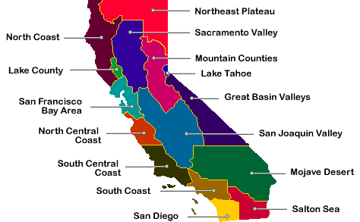

Greater Sacramento Federal Nonattainment Area (SNFA)

The Greater Sacramento Federal Nonattainment Area includes part or all of Placer, Sutter, Yolo, Sacramento and El Dorado Counties. The SNFA fails to attain the Federal health-based ambient Air Quality Standard for Ozone, which requires a coordinated modeling, plans and rules to comply with the Federal Clean Air Act.

Southern Sutter County (generally south of Subacco Road) is part of the SNFA and therefore slightly different rules are in place for activities in that area. This includes more stringent regulations, lower permitting thresholds and limiting burning in the area on days when ozone is elevated. Very few permitted sources are in that area at this time, although that may change with new development in far southern Sutter County.

US EPA

The District is delegated to enforce portions of the Clean Air Act in Sutter and Yuba Counties by US EPA. In addition, the District is responsible for issuing Federal Clean Air Act Permits under the New Source Review (NSR), Prevention of Significant Deterioration (PSD) and Title V (Major Federal Source) Programs. Permits issued by the District under these programs are “Federally Enforceable” meaning they carry the same legal authority as if they were issued by the US EPA. In addition, the US EPA has general program oversight of the District’s permitting activities. EPA can conduct its own inspections of any sources in the District, including those with NSR, PSD and Title V permits.

The US EPA, ARB, the Sac Region Air Districts and SACOG work jointly in preparing the State Implementation Plan (SIP) which is approved by EPA. The SIP is a requirement of the CAA for areas that do not meet the ambient air quality standards. It includes modeling and analysis to demonstrate an area can meet an attainment deadline and commitments for future rule adoptions needed to meet federal air quality standards. The SIP also contains adopted District Rules that, once approved by the US EPA, are also “federally enforceable.”

**District Board**

The District Board is made up of 9 elected officials from local government entities in Yuba and Sutter Counties. Yuba and Sutter County appoint 5 members[5] and each incorporated City appoints one member. The Board member terms typically end at the beginning of the calendar year, however in a case of a delay in making appointments they may continue to serve beyond January 1.

The Board appoints members to various committees and other assignments as needed. In general, the Board has attempted to maintain some geographic equity when making committee appointments (i.e. not have all the members of the Committee be from one of the member counties).

Role of the Board

The Board has several primary roles,

1. Appoint the Air Pollution Control/Executive Officer for the District
2. Adopt the annual budget, including the number and type of positions (H&S § 40705-06)
3. Adopt and amend District regulations
4. Appoint members of the Hearing Board (H&S § 40800)
5. Employee negotiations (generally on three-year schedule)
6. Authorize and oversee litigation (excluding some enforcement matters)

Unlike a County Board of Supervisors or City Council the FRAQMD Board does not have a direct role in the permitting process, even as an appeals body. All permit and abatement order appeals go to the Hearing Board and, if necessary, judicial review (H&S § 40864). There is no individual permit appeal to the District Board.

Enforcement actions are the responsibility of the APCO[6] (H&S § 40752), although some litigation may be brought to the Board for approval.

Board Calendar

The Board meets at 4:00pm on the first Monday of every other month, starting in February[7]. Special meetings are called by the Chair when needed.

Committees and Ad-Hoc meet when needed and the schedules are coordinated around the members availability.

Board Policies

Staff is actively working to review and bring to the Board proposed updates to a number of policies.

**Hearing Board**

Hearing Board Members (5) are appointed by the District Board to three-year terms. The Health and Safety Code (H&S § 40801) specifies the Hearing Board should include medical, technical and legal professionals as well as members of the general public, although in smaller Districts (like FRAQMD) the Board may appoint anyone to the Hearing Board if there is not a qualified professional applicant.

Hearing Board Role

The Role of the Hearing Board is to be an independent body to hear appeals of permit denials, appeals of permit conditions, abatement orders and requests for variances from permit conditions. These actions are typically rare, but when they do occur, they can be very complex and time consuming.

The moving party in a Hearing Board action can be the permit applicant, a member of the public or the District. Most hearings are handled as a legal hearing with briefs and evidence rules.

The Hearing Board Chairperson can approve limited term emergency variances on very short notice which can be extended by the full Hearing Board at a public meeting.

Recently the Legislature authorized the APCO to issue emergency abatement orders in some limited situations which can go into effect immediately but have a limited term.

Hearing Board Member List (1/2025)

William Appleby (Health Care) – Chair

Sean Minard (Engineer) – Vice Chair

Larry Munger (Public Member)

LuAnn McKenzie (Public Member)

David Smith (Public Member)

**Funding**

The District is funded primarily though permit and user fees. The District does not have taxing authority and does not receive any tax dollars from local government[8]. The two primary sources of revenue are permit fees and small vehicle registration assessment. Additional funding is provided by administering various state and federal grant programs, from state and federal grants (when available) and penalties (H&S § 40701.5).

Like most local Governments, the District’s initial budget is adopted in June for the fiscal year that begins July 1. The final budget is usually adopted in August and contains minor corrections to the adopted initial budget.

The bulk of District’s funds are on deposit with Yuba County, and, per the Government Code, the District is subject to an outside audit each year. Audits are presented to the Board. The District does have outside bank accounts for electronic transactions.

The District’s fiscal health is very much “boom and bust” when the economy is strong permit activity tends to be robust and state funding tends to increase. However, when the economy drops off enforcement work increases, and state and federal funding disappears. For this reason, the District always tries to maintain significant reserves to get through lean times.

Budget and Fee Adjustments

State Law and most District fees include an automatic adjustment which is implemented as part of the annual budget. Although often called a “CPI Adjustment” the amount of the adjustment actually is “up to the CPI.” Amounts lower than the CPI can be proposed if District operational costs are lower[9]. For 2024 the increase was 4.2%.

Because of the annual adjustment, the District does not increase fees as frequently as other agencies, most current District fees were originally adopted in the early 2000s.

How Individual Fees Are Calculated

The District operates on a billable hour system for most permits (Burn permits are the notable exception). There is a base fee, set by regulation, and then District staff bill the time spent working on each permit individually. This means that initial permits, which require more communication and inspections, receive a larger bill in the first few years. In later years the annual bill should drop significantly as less District time is needed for a mature facility. The billable hour system also ensures that sources that do not have “all their ducks in a row” are likely to pay higher fees than those facilities that require less staff time from the District.

**District Divisions**

Executive

The Executive Division consists of the APCO/EO with the primary job of overseeing all District operations.

Administration

The Administrative Division (3 FTE) manages all Fiscal, Human Resources, Risk Management, Clerk of the Boards (District Board and Hearing Board) and front counter functions. The Administrative Division also drafts the annual budget, with direction from the APCO, for Board consideration.

Planning and Engineering

The Planning and Engineering Division (4 FTE) is responsible for coordinating with Transportation and Land Use agencies, developing air quality attainment and maintenance plans, coordinating development of the federal ozone SIP with the other Sacramento Region Air Districts, implementing grant programs, conducting public outreach, drafting new rules and regulations, processing permits and annual permit renewals, calculating emissions and reporting emissions inventories to the ARB and US EPA, and a variety of other technical tasks.

Air District Permits

An air district permit must be issued prior to the building or installation of a regulated device. A permit ensures that the device does not prevent or interfere with the attainment and maintenance of any air quality standard, and that the device will comply with the rules and regulations of the District, ARB, and US EPA. Permits are renewed annually and may also be modified at the request of the owner/operator throughout the year.

Figure 3 - An example of a permitted source (backup generator)

Grant Programs

The Planning and Engineering Division administers several incentive grant programs with both local funding and funding from the State. Available annual grant funding varies by program from around $150,000 in the locally funded Blue Sky Grant to over $1 million in the cap and trade funded grants. Most of the funding is for agricultural equipment upgrades and school bus replacements. A list of active grant programs is online at [www.fraqmd.org/grant-programs](https://www.fraqmd.org/grant-programs).

Figure 4 - An example of a new lower emissions tractor partially funded under the District’s grant programs.

Rules

The District’s Planning and Engineering Division is also responsible for developing new rules as needed. Generally, FRAQMD rules are similar or identical to rules adopted by the Air Districts in California, for example in some cases the State prepares a “model rule” which FRAQMD Staff will fine tune to our local situation. Similarly, the Sacramento Region District may develop a similar rule to meet a Sacramento Region requirement. This rule is then separately adopted by each District in the Region.

District rules generally are “technology neutral” in that they do not require the use of particular technologies or emissions control equipment, but rather set emissions levels which cannot be exceeded. Industry then has maximum flexibility to innovate and find new ways to obtain the required reductions for the lowest cost.

Rule Adoption Process

All District rules must be adopted at a public hearing of the District Board. Prior to that adoption District staff may conduct one or more public workshops, or at least open a public comment period[10]. In addition, all proposed rules are reviewed by ARB or EPA (or both).

Any proposed rule which will be adopted into a “State Implementation Plan” (SIP) for US EPA must also be adopted by the ARB Board at a noticed public hearing. Following this EPA will conduct their public notice process through the Federal Register and eventually include the rule in the Code of Federal Regulations (CFR). Once a rule has been included in the CFR it is considered “Federally Enforcable” by US EPA.

Emission Reduction Credits

The Planning and Engineering Division also implements the Emissions Reductions Credit (ERC) program. Emission Reduction Credits are real property generated by reducing pollution generating activities below legally required levels. In FRAQMD, most of our ERCs have been generated by farmers choosing to reduce field burning below the levels required by law. Once approved by the District, the ERC is held by the farmer and can be sold to a company that needs an ERC to put in new equipment. ERCs can be sold or traded within the Air Basin in which they were created. The District does not profit from the sale of ERCs, it is simply the agency which tracks the ERC to make sure they are real, enforceable, permanent, and quantifiable.

Compliance

The Compliance Division (4 FTE) conducts annual inspections, runs the agricultural burn program, investigates complaints, issues violations and takes other enforcement action as needed. Additionally, inspectors conduct field inspections for grant programs and registration programs.

Burn Program

The District runs the open burn program year-round. All burning must comply with District Regulations, State Law, the Fire Code and any local ordinances.

Inspection Program

The Compliance Division is responsible for all permitted sources, currently around 1,000, and all burn permits, currently around 1,500, issued within the District. Routine inspections help ensure emission reductions written into regulations are achieved in practice. All District permits are inspected annually. Larger federal facilities (Title V) have more complex inspection requirements.

Figure 5 - An example of a permitted source dumping wood shavings into a tailer for reuse elsewhere

The Compliance Division also inspects agricultural engines under the District’s Agricultural Engine Registration Program, and portable engines registered in the California Portable Equipment Registration Program (PERP). The District also conducts several inspections under MOUs between the District and various agencies, these include landfills, gas wells and some toxic cleanup sites at Beale AFB.

Complaint Program

The Compliance Divisions investigates air quality complaints. Complaints can include public nuisance, dust or emissions, illegal disposal by open burning, unpleasant or noxious odors, and general complaints regarding permitted sources. In addition, the District frequently receives complaints which are not under the District’s jurisdiction and must be referred to other agencies, such as pesticide application complaints and land use complaints.

Enforcement

The regulations enforced by the District have the force of law and therefore can be enforced through the criminal justice system (including jail time), civil legal action or administrative penalties. Because of the potential for criminal charges information on investigations is strictly limited. The District Board adopts the rules and policies governing the enforcement program but is not involved in individual cases.

Mutual Settlement Program

The Compliance Division resolves non-criminal violations of Federal, State and District regulations through the Board Adopted Mutual Settlement Program (MSP). The MSP process typically resolves violations through an administrative process with only a very few violations needing civil legal action. Most Mutual Settlements involve a suspension which suspends part of the penalty provided the source remains in compliance for a probationary period (typically 3 years).

**Legal**

The District uses Sutter County Counsel as our primary legal representation. In addition, ATA Law Group is used for complex enforcement cases as needed. Enforcement cases may also be referred to US Attorney, State Attorney General and District Attorney as required.

**Burn Program**

The District’s Burn Program complies with the applicable State and Federal Laws. The District’s program is no more stringent than any other Air District in the Sacramento Valley, except as required by Federal law due to our local air quality status.

**Burn Days**

One of the most common issues brought up to both staff and the Board is burn days. Some members of the public feel there are too many, some feel there are too few, others complain that burning is limited on certain days.

The only agency that can make a day a burn day is the Air Resources Board following the California Code of Regulations Title 17 section 80250 (for the Sacramento Valley). All other agencies, including FRAQMD can only change a burn day to a no-burn day based on their own policies. The agencies involved each day include the following –

1. Sacramento Valley Basin Control Council (Rice burn allocations)
2. FRAQMD
3. Local Fire Agencies for LRA (Local Responsibility Area)
4. CalFire for SRA (State Responsibility Area)
5. USFS and USAF for FRA (Federal Responsibility Area)

Even when all the agencies agree it is a burn day ARB, the BCC or FRAQMD may limit the acres of types of burning based on any number of local factors. For example, it is common in the winter to have poor air movement until mid-day, FRAQMD will only allow burning after noon on those days and may limit burning to “pruning’s only (no whole trees or fields).”

FRAQMD makes decisions to call a no burn day based on local smoke impacts, for example if the area is being impacted by regional wildfire smoke. FRAQMD also manages burning when allowed to minimize impact to populated areas, for example not allowing burning near Sacramento when smoke will travel to the South.

The overall goal of the burn program is to ensure burning does not negatively impact local and regional air quality. To achieve this goal the atmosphere must support smoke dispersion and transport out of the area. It is common to burners to see their smoke plume going up and assume it is not impacting anyone downwind, when in fact the smoke is dropping on somebody a few miles away.

Managing the complex regulations and interagency relationships around the Burn Program is very difficult.

District staff has no way to overrule other agency decisions about burn day status, if for example the USFS makes it a “no burn day” in their jurisdiction the District cannot change that decision.

**State law prohibits all burning** – unless it falls into one of a limited number of exemptions.

**Who can burn?**

All businesses are prohibited from all burning (H&S Code 41800). This includes both for profit and non-profit businesses (like Churches). The only businesses that are exempt is agriculture (including forestry).

Agricultural burning can only be conducted on land used for crop production (i.e. not processing facilities) and must comply with strict restrictions on impacts to neighboring properties (H&S Code 41850). “Agriculture” is defined by the District as being an activity done for profit and being the primary activity on the parcel (copy of IRS Schedule F can be required).

Residential burning is allowed, but only on properties with two or fewer residences (H&S Code 41806). Mobile home parks and apartment complexes cannot burn. Residential burning is banned in most cities in the District by local fire authorities.

Burning for single family (one) property development is allowed in rural areas with a District Permit and approval. (H&S Code 41802).

Burning conducted by fire agencies and for training is generally exempt (H&S Code 41801), but cannot be used to “get around” the restrictions above.

**What can be burned?**

Burning is limited to natural vegetation that grew on the property.

Burning of anything other than natural vegetation is prohibited, including any milled wood, pallets, fruit boxes, cardboard, construction debris, plastic, metal, trash, car bodies, human waste, animal carcasses, waste oil, campers etc.

Material cannot be moved to a different property (non-adjoining) to be burned.

Figure 6 - An example of an illegal burn pit found by District inspectors.

**Exemptions to Burn Regulations?**

There are some exemptions, but they are very narrow and limited and usually require approval of an outside agency (such as the Ag Commissioner) or an Emergency Declaration (H&S Code 41809, 41855 and others).

**Functions *not* done by FRAQMD**

There are a number of functions which the public believes are done by the Air District, but actually done by other entities.

Air Monitoring

Both official air monitoring sites in the District (Yuba City and Sutter Buttes) are run by the Air Resources Board. Air monitoring data collected by the state is available on the “Air Now” website run by EPA. FRAQMD does not run any official (reported to EPA and ARB) Air Monitoring sites. The District does have a small network of smoke monitors in both counties to help deal with wildfire impacts. Additionally, the District can do some limited temporary air monitoring in response to wildfires or other emergencies.

Asbestos

Many Air Districts in California have been delegated by EPA for Asbestos emitted from Renovation and Demolition Activities, FRAQMD has never accepted this delegation. For many years the Air Resources Board ran the local program, however they have recently shut down their program so technically EPA is the responsible agency.

The District does regulate naturally occurring asbestos under state law which is present in some areas in the foothills and can be disturbed by grading and construction activities, but this is generally an uncommon occurrence.

Workplace Air Quality

The District does not enforce workplace safety regulations. Those are enforced by CalOSHA, MSHA (Mine Safety and Health Administration) and other agencies. This includes CalOSHA’s recent rules about employee exposure to Wildfire Smoke. Generally, the District is not involved until the emissions cross a property line.

Indoor Air Quality

The District does not enforce indoor air quality rules, including rules restricting smoking near doorways. The District’s authority is limited to “ambient outdoor air.”

Smog Check/ARB Truck rules

While the District does have authority to enforce portions of the Vehicle Code, such as for excessive smoke or Diesel truck and bus idling, the District is not involved in either the Smog Check Program or ARB’s Diesel Truck rules - including answering public inquiries about these programs.

Pesticide regulations

Pesticides are regulated by the Agricultural Commissioner and the State Office of Pesticide Regulation. The District does permit a few agricultural processing facilities that release pesticides as part of an industrial process with other emissions. Complaints about pesticides from the public should be directed to the Agricultural Commissioners.

1. Bay Area and Southern California established local Air Districts in the 1950s
2. Or registration which is functionally identical.
3. Ambient Air is generally defined as outdoor air that the general public is exposed to. Indoor air is not subject to District regulations, nor are occupational exposures of employees (Cal-OSHA).
4. The term “ARB Board” is somewhat redundant since the ‘B’ in ARB stands for Board, however the acronym is in wide usage. Generally, when someone says ARB they are referring to staff, when they say ARB Board, they are referring to the Appointed Board.
5. Three from one county and two for the other, alternating years.
6. Following the guidance in Federal and State law as well as Board Adopted Regulations and Policies.
7. Excluding holidays which are normally rescheduled for one week later
8. State Law does allow the entities who appoint members to the District’s Board to be assessed a “per-capita general fund assessment” however this has never been implemented in FRAQMD (H&S § 40705.5(b)).
9. This rarely occurs since so much of District expenses are for CalPERS pension and healthcare, both of which increase much greater than the CPI each year.
10. For controversial or new regulations the District will typically hold a public workshop, for minor rule clean up or rule clarifications the APCO may select to hold a public comment period.